Michael Hayes

Blake Lasky

11/8/15

Pre-Lab 8

Wednesday Lab Session

Dr. Sangregory

1. Design Description

We are creating a cube-mover style video game using a keyboard and VGA monitor both connected to an FPGA board. The WASD keys control a colored cube which must traverse the screen collecting other colored cubes. With each cube collected, the score, which is displayed using the FPGA 7-segment displays, is increased. The screen background can be adjusted to display any combination of Red, Green, and Blue rings simply by toggling switches 9, 8, and 7 on the FPGA board. This can lead to a unique gameplay, and added difficulty.

1. Basic Block Diagram

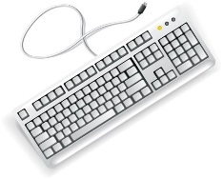

**Figure 4: Output Controller**

**Key components**

**Block Location Data**

**Figure 2: Player Mover**

**Key components**

**Figure 3: Game Controller**

**Key components**

**Block Location Comparison**

**Other Block**

**Location Register**

**Switches and Color Information**

**Figure 1: Basic Block Diagram**

**Vertical Position Register**

**Horizontal Position Register**

**Output Controller**

**Game Controller**

**Player Mover**

**7-Seg Displays**

**Score Register**